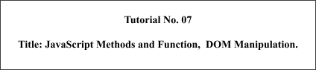

# Batch:B2 Roll No.:16010421119 Tutorial:7

**Aim**: To implement javascript methods, functions and Event Handling to manipulate DOM

# Resources needed: Notepad++, Web Browser Theory:

JavaScript is a scripting language produced by Netscape for use within HTML Web pages.

JavaScript is loosely based on Java and it is built into all the major modern browsers. JavaScript is a lightweight, interpreted programming language, Complementary to and integrated with Java, Complementary to and integrated with HTML, Open and cross-platform and is case sensitive.

# Placing JavaScript in HTML document:

There is a flexibility given to include JavaScript code anywhere in an HTML document. But there are the following most preferred ways to include JavaScript in your HTML file:

1. Script in <head>...</head> section.
2. Script in <body>...</body> section.
3. Script in <body>...</body> and <head>...</head> sections.
4. Script in and external file and then include in <head>...</head> section.

An example of it is shown below:

<html>

<body>

<script language="javascript" type="text/javascript">

<!--

document.write("Hello World!")

//-->

</script>

</body>

</html>

# Looping and Control statements in JavaScript:

* if statement syntax:

if (expression){

Statement(s) to be executed if expression is true

}

* if else statement syntax:

if (expression){

Statement(s) to be executed if expression is true

}else{

Statement(s) to be executed if expression is false

}

* else if ladder syntax: if (expression 1){

Statement(s) to be executed if expression 1 is true

}else if (expression 2){

Statement(s) to be executed if expression 2 is true

}else if (expression 3){

Statement(s) to be executed if expression 3 is true

}else{

Statement(s) to be executed if no expression is true

}

* switch statement syntax: switch (expression)

{

case condition 1: statement(s) break;

case condition 2: statement(s) break;

...

case condition n: statement(s) break;

default: statement(s)

}

* While Loop

while (expression){

Statement(s) to be executed if expression is true

}

* do- while Loop do{

Statement(s) to be executed;

} while (expression);

* for Loop

for(initialization; test condition; iteration statement){ Statement(s) to be executed if test condition is true

}

for (variablename in object){ Statement or block to execute

}

# Syntax for JavaScript functions:

function concatenate(first, last)

{

var full;

full = first + last; return full;

}

To invoke a function somewhere later in the script, you would simple need to write the name of that function.

# Javascript Dialog boxes:

JavaScript supports three important types of dialog boxes. These dialog boxes can be used to raise and alert, or to get confirmation on any input or to have a kind of input from the users:

* Alert Dialog Box:

An alert dialog box is mostly used to give a warning message to the users. alert("Warning Message");

* Confirmation Dialog Box:

A confirmation dialog box is mostly used to take user's consent on any option. It displays a dialog box with two buttons: OK and Cancel.

var retVal = confirm("Do you want to continue ?");

* Prompt Dialog Box:

The prompt dialog box is very useful when you want to pop-up a text box to get user input. Thus it enables you to interact with the user. The user needs to fill in the field and then click OK.

var retVal = prompt("Enter your name : ", "your name here");

# In built objects in JavaScript:

A String object encapsulates a sequence of characters, enclosed in quotes

properties include :

* length : stores the number of characters in the string
* charAt(index) : returns the character stored at the given index (as in indices start at 0)
* substring(start, end) : returns the part of the string between the start (inclusive) and end (exclusive) indices
* toUpperCase() : returns copy of string with letters uppercase
* toLowerCase() : returns copy of string with letters lowercase

Arrays store a sequence of items, accessible via an index since JavaScript is loosely typed, elements do not have to be the same type. To create an array, allocate space using new (or can assign directly):

items = new Array(10); // allocates space for 10 items

items = new Array(); // if no size given, will adjust dynamically items = [0,0,0,0,0,0,0,0,0,0]; // can assign size & values []

To access an array element, use [] (as in C++/Java) for (i = 0; i < 10; i++) {

items[i] = 0; // stores 0 at each index

}

The length property stores the number of items in the array.

The Date object can be used to access the date and time. To create a Date object, use new & supply year/month/day/… as desired

today = new Date(); // sets to current date & time newYear = new Date(2002,0,1); //sets to Jan 1, 2002 12:00AM

Methods can access individual components of a date includes: newYear.getYear()

newYear.getMonth()

newYear.getDay() newYear.getHours() newYear.getMinutes() newYear.getSeconds() newYear.getMilliseconds()

# Document Object Model(DOM):

DOM Objects can be referenced using JavaScript

* by their id or name (this is the easiest way, but you need to make sure a name is unique in the hierarchy)
* by their numerical position in the hierarchy, by walking the array that contains them
* by their relation to parent, child, or sibling (parentNode, previousSibling, nextSibling, firstChild, lastChild or the childNodes

# JavaScript and DOM:

JavaScript is used to manipulate the objects. For this id of an element is needed to be passed to method getElementById() of document object, which returns the element with the given id. And then we can alter its property.

# For example,

if you want to find a <p> with the id of "cool", use:

getElementById("cool") document.getElementById(item).style.backgroundColor =color;

to access the elements nested in <p> tag we can use, document.getElementById(item).childNodes[1].style.backgroundColor =color;

# Document Object:

innerHTML is a property of any document element that contains all of the html source and text within that element.

getElementById("cool").innerHTML ="new text string";

# Methods:

document.write(…) : method that displays text in the page

document.URL : property that gives the location of the HTML document

document.lastModified :property that gives the date & time the HTML document was last changed

# Activity:

* 1. Explore different methods of in-built JavaScript objects date, string, math, array etc.
  2. Include at least two significant methods of some of these objects in your script
  3. Extract elements of document using DOM and manipulate same using methods

# Results: (Program printout with output)

**Code:**

**Index.html**

<!DOCTYPE html>

<html lang="en">

<head>

<meta charset="UTF-8">

<meta http-equiv="X-UA-Compatible" content="IE=edge">

<meta name="viewport" content="width=device-width, initial-scale=1.0">

<link rel="stylesheet" href="./styles.css">

<title>DOM Manipulation</title>

</head>

<body>

<div class="images">

<img src="./img.jpg" class="img" alt="img1">

<img src="./img.jpg" class="img" alt="img2">

<img src="./img.jpg" class="img" alt="img3">

</div>

<div class="buttons">

<button class="btn" onclick="function1()" id="btn1">Opacity Change</button>

<button class="btn" onclick="function2()" id="btn2">Width/Height Change</button>

<button class="btn" onclick="function3()" id="btn3">Border Radius Change</button>

</div>

<div class="form">

<p id="text1">

This is Aarya

</p>

<button onclick="textFunction()" class="btn">Change the Text on Click</button>

<button onmouseover="textFunction()" class="btn">Change the Text on Mouse Over</button>

<button onmouseleave="textFunction()" class="btn">Change the Text on Mouse Down</button>

</div>

<script src="./script.js"></script>

</body>

</html>

Style.css:

body {

width: 100%;

height: 100%;

box-sizing: border-box;

}

.images{

display: flex;

gap: 10px;

justify-content: space-around;

}

.btn

{

margin: 10px;

}

.buttons{

display: flex;

gap: 10px;

justify-content: space-around;

}

.img{

width: 500px;

height: 700px;

}

.form{

margin: 20px;

text-align: center;

}

Script.js

var img1 = document.getElementsByClassName('img')[0]

var img2 = document.getElementsByClassName('img')[1]

var img3 = document.getElementsByClassName('img')[2]

function function1() {

img1.style.opacity = '0.4'

}

function function2() {

img2.style.width = '100px'

img2.style.height = '100px'

}

function function3() {

img3.style.border = '5px solid black'

img3.style.borderRadius = '100px'

}

var text = document.getElementById('text1')

var count = 0

function textFunction() {

if(count%3===0)

{

text.innerHTML = 'This is Dhairya'

count++

}

else if(count%3===1)

{

text.innerHTML = 'This is Aarya'

count++

}

else

{

text.innerHTML = 'This is Aditya'

count++

}

}

Output:

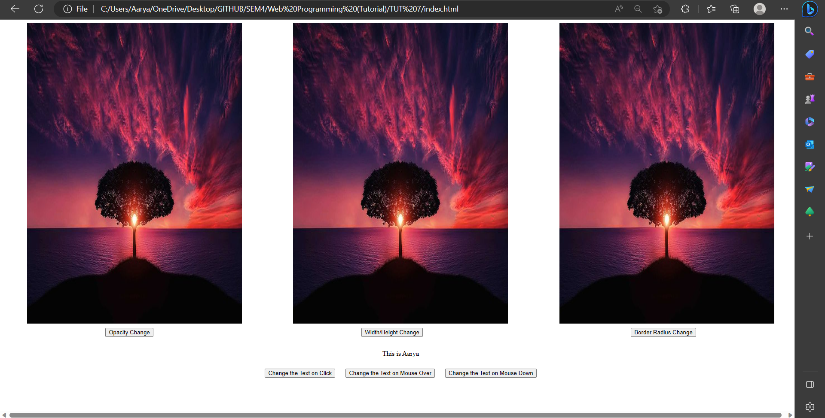

**Questions:**

Q1) Explain with examples on how Javascripts help in creating dynamic HTML page.

Ans:

JavaScript is a programming language that is commonly used to create dynamic HTML pages. It allows developers to add interactive and responsive features to web pages, making them more engaging and user-friendly. Here are some examples of how JavaScript can be used to create dynamic HTML pages.

1. Event Handling: JavaScript can be used to handle user events such as mouse clicks, key presses, and form submissions. For example, a developer can use JavaScript to validate user input in a form and display error messages if the input is invalid.
2. DOM Manipulation: JavaScript can be used to manipulate the Document Object Model (DOM), which represents the structure of a web page. This allows developers to dynamically update the content and style of a web page based on user interactions or other events. For example, a developer can use JavaScript to change the color of a button when the user hovers over it.
3. Asynchronous Operations: JavaScript can be used to perform asynchronous operations such as fetching data from a server or updating the content of a web page without reloading the entire page. For example, a developer can use JavaScript to load new content into a web page when the user scrolls to the bottom of the page.

Q2) What is DOM? Explain.

Ans: DOM stands for Document Object Model and it is a programming interface that allows JavaScript to access and manipulate the structure, content, and style of an HTML document. The DOM represents the HTML document as a hierarchical tree structure, where each element in the HTML document is represented as a node in the tree. This allows JavaScript to access and modify the properties and attributes of each node, such as its content, style, and position on the page.

When a web page is loaded into a web browser, the browser creates a DOM tree based on the HTML code. This DOM tree can then be manipulated by JavaScript to dynamically update the content and style of the web page without reloading the entire page. For example, JavaScript can be used to add or remove elements from the DOM tree, change the text or image content of an element, or modify the CSS styles of an element.

# Outcomes:

CO3: Apply JavaScript and JSON for web application development

**Conclusion: (Conclusion to be based on the outcomes achieved)**

**We can conclude that we have learnt about event-handling.**

# Grade: AA / AB / BB / BC / CC / CD /DD

Signature of faculty in-charge with date

# References:

**Books/ Journals/ Websites:**

* “Web technologies: Black Book”, Dreamtech Publications
* [http://www.w3schools.co](http://www.w3schools.com/)m